Group Name: Python Warriers

Team members:

Rajesh Paine, 26BCE10453
Vaibhav Gujrati, 26BCE10457
Sitanshu Singh, 26BCE11383
Prashant Rawat, 26BCE10727
Mayank Yadav, 26BAI10741

Algorithm: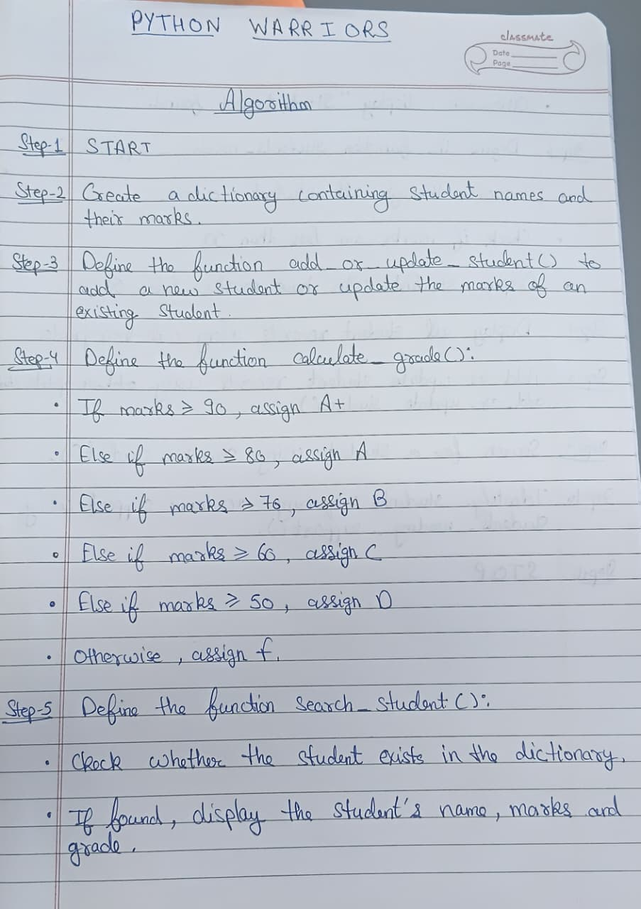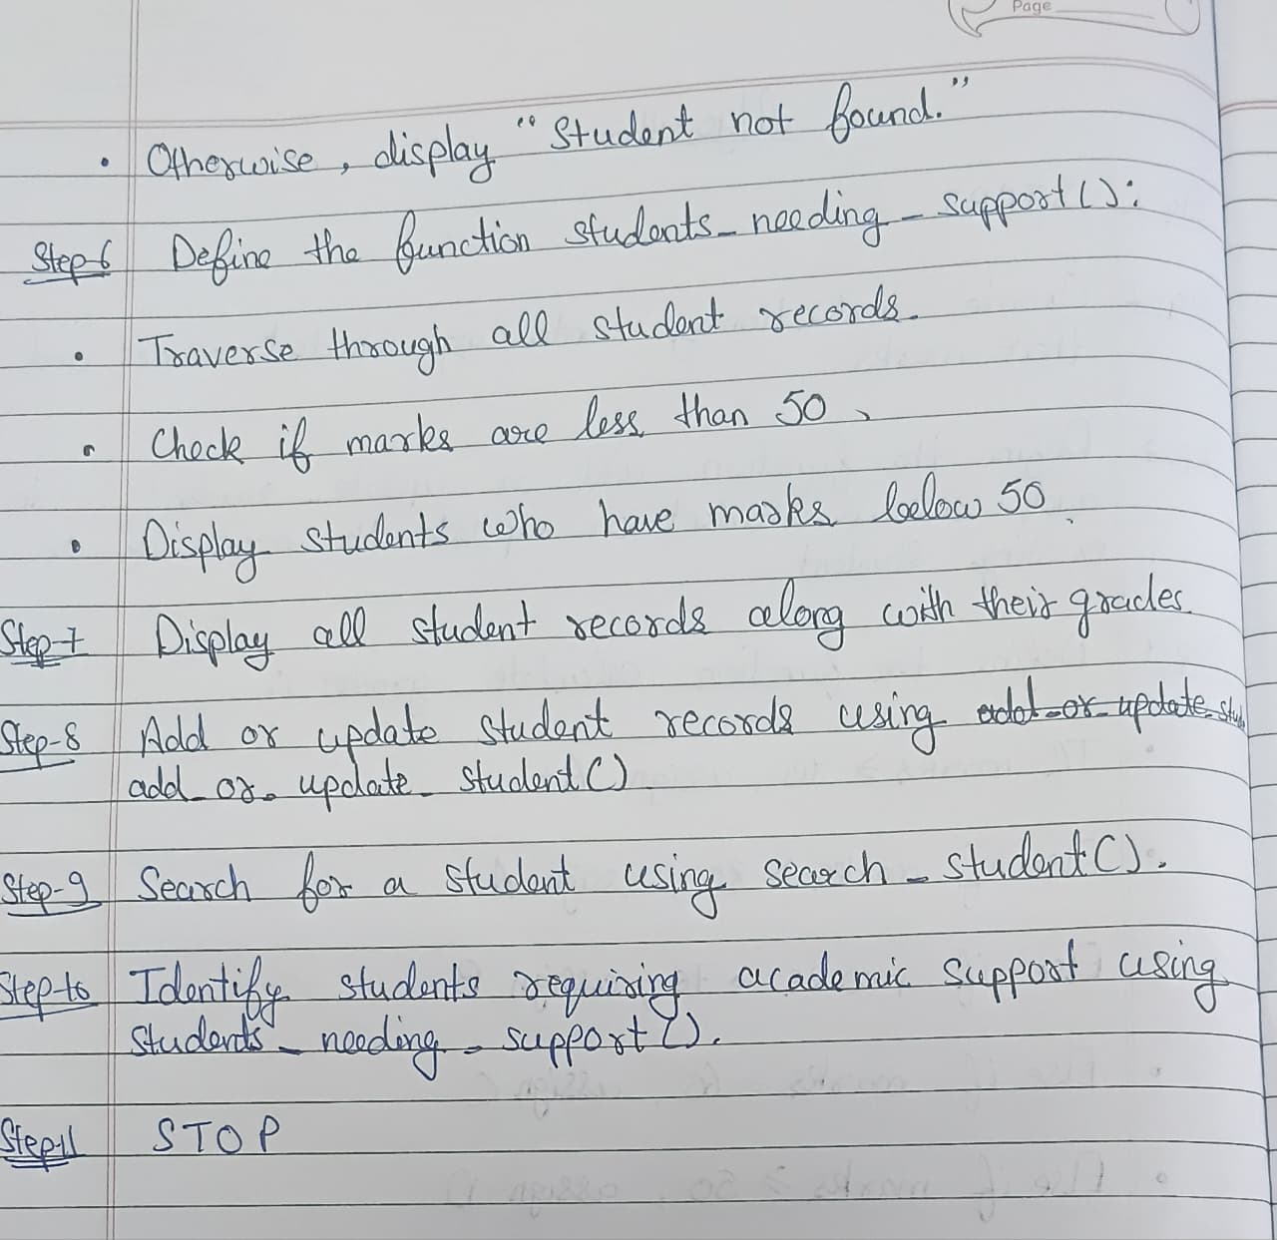

Flowchart: 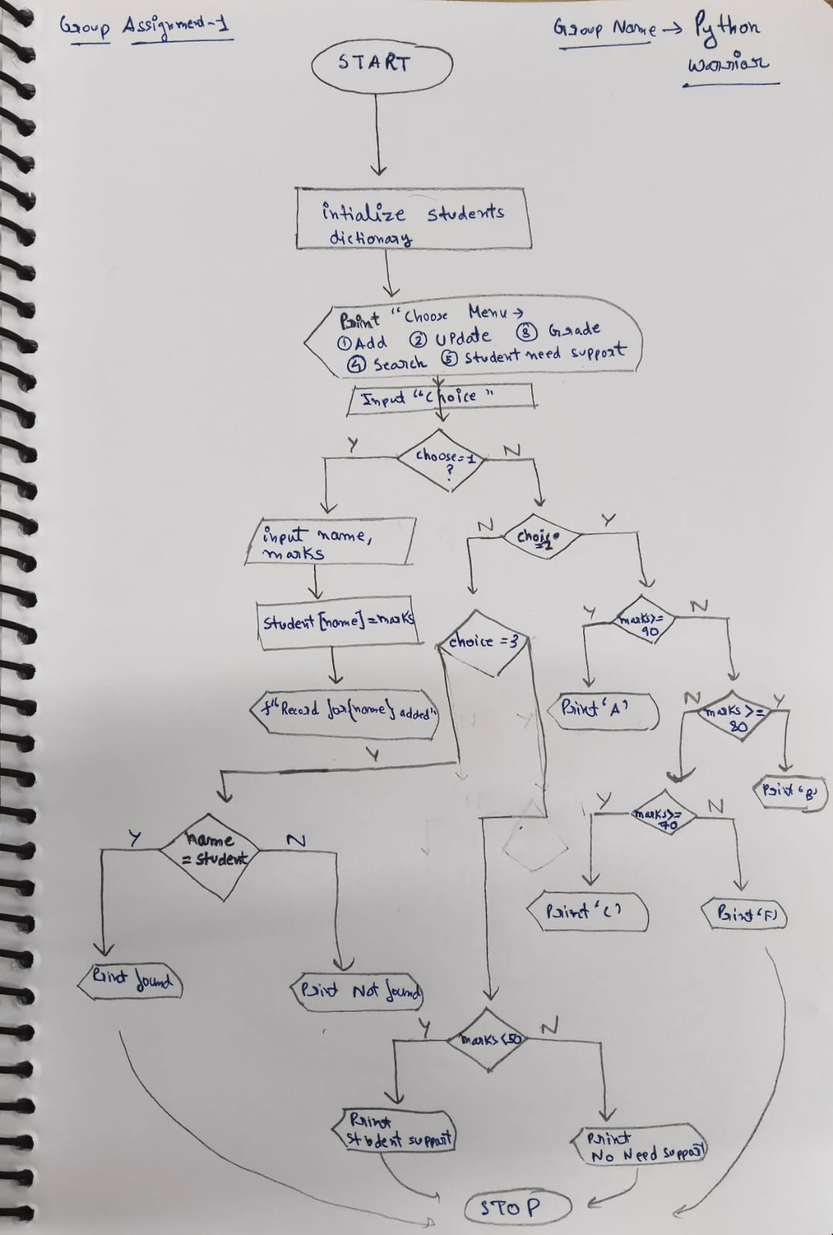

Code:

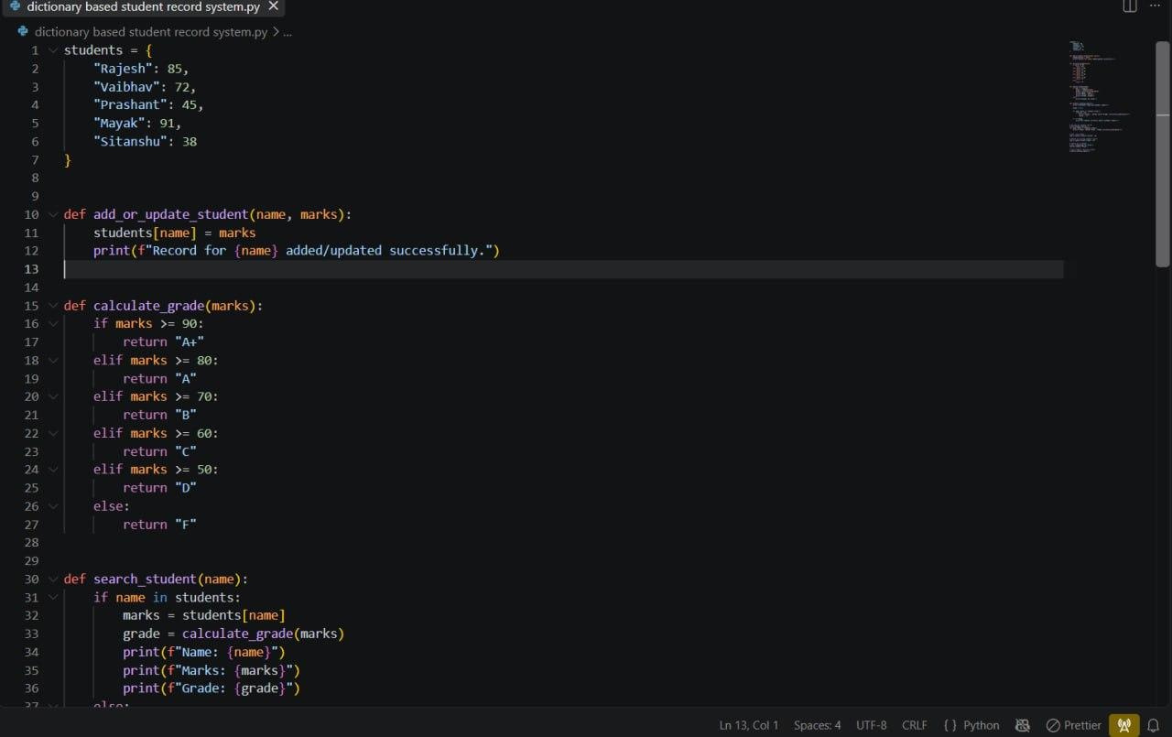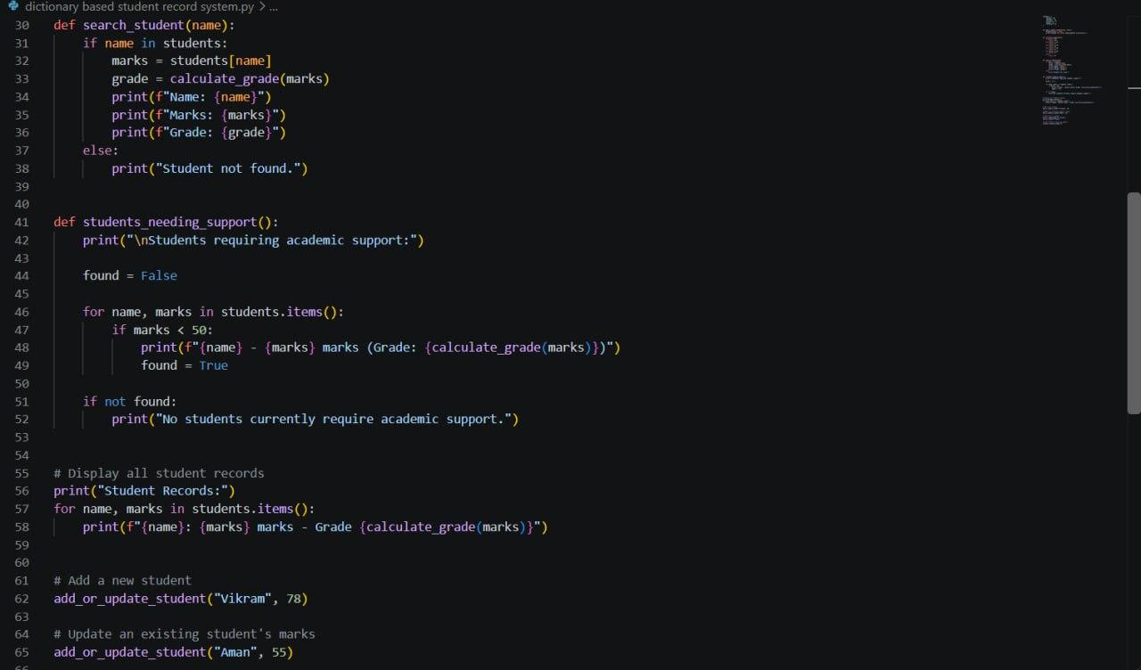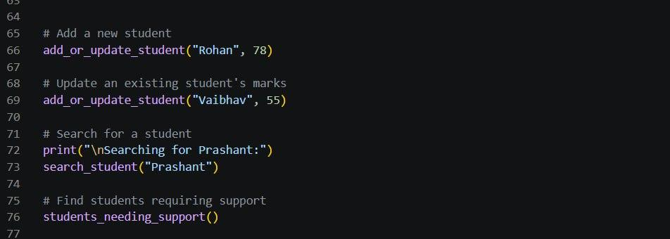

Output:

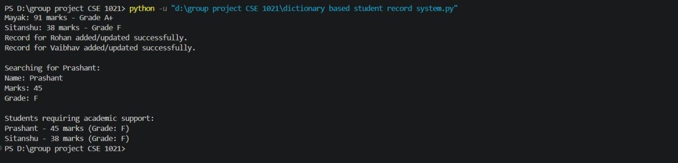

Efficiency/Algo Analysis:

